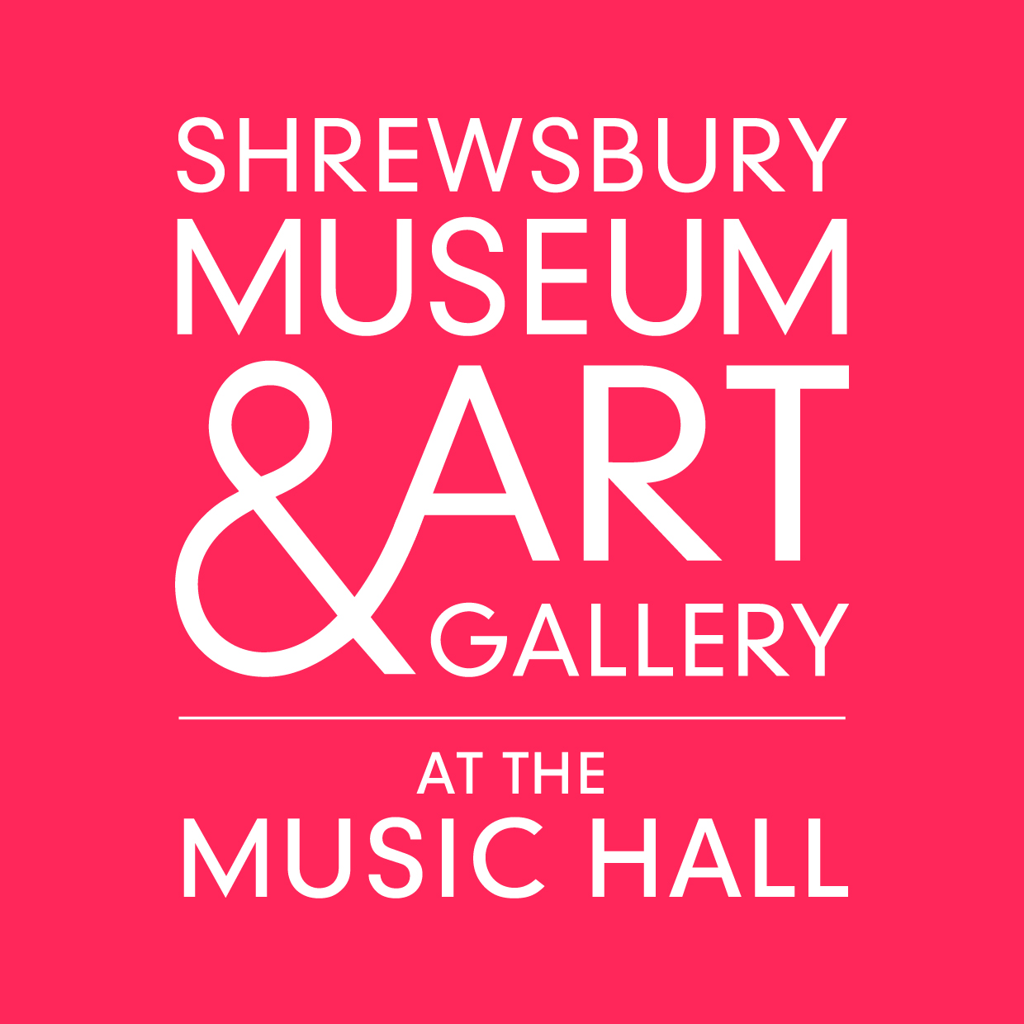

Roll up, roll up
The curtain is about to be raised on
a curious collection of the old, the new and the extraordinary

at the spectacular

Shrewsbury Museum & Art Gallery

On 1 April 2014, doors will open to the new Shrewsbury Museum & Art Gallery, a project five years in the making that will take visitors on a journey of discovery right back to the Bronze Age. This will be the landmark attraction for what is already one of England’s most celebrated Tudor market towns.

Shrewsbury’s Victorian Music Hall and one of the country’s rarest 13th century mansions have been the focus of a groundbreaking restoration project to form a new home for the museum. The project has enabled the very best of the county’s entire collection to be completely reimagined for a modern audience.

Pieces dating back to pre-history and Roman times will sit alongside a rolling programme of contemporary art, opening with an exclusive exhibition from Frank Cohen’s internationally acclaimed collection.

The Museum & Art Gallery is owned and managed by Shropshire Council. This project, which has cost more than £10m, is a significant investment in Shropshire’s tourism offer and will welcome visitors from far and wide to share in its story and experiences.

Visitor Information

Opening Times
Daily from 1 April to 30 September
10am – 5pm
Tuesday – Sunday 1 October – Easter
10am – 4.30pm

Admission Prices
Adult (18+): £4.00
Senior citizens (over 60): £3.50
Children (5-17): £2.00
Children (0-4): Free of charge

Location and Contact
Shrewsbury Museum & Art Gallery
The Square
Shrewsbury
Shropshire
SY1 1LH
Tel: 01743 258885
www.shrewsburymuseum.org.uk
Transformation of epic proportions
returns a
national treasure to its hey-day splendour

Shrewsbury Museum and Art Gallery comprises a grade II and a grade II* listed building that have been transformed into one dramatic complex overlooking the town’s main square. The unusual architecture and rich history are just as intriguing as the artefacts and art works that are housed here.

The town’s Music Hall, built in 1840 and designed by Edward Haycock Snr, forms the main structure. Classical in style, it is dominated by towering stone columns and immense sash windows. Always at the centre of the community, it has had several lives as a place of entertainment and, more unusually, being used as the base for the town’s fire service.

The oldest part of the complex is Vaughan’s Mansion, which dates back to 1290. There are only a handful of these urban, stone townhouses left in the country, and Vaughan’s is the only one to be found in Shropshire. The house originally belonged to William Vaughan, a local merchant who was one of the wealthiest men in the town.

Vaughan’s Mansion was later bought by major landowners, the Mytton family, whose family coat of arms was discovered on the timbered exterior during the restoration. The property went on to adopt various guises over the next centuries, housing the Shrewsbury museum collection in the 19th century and later becoming an art academy and a Freemasons’ hall. Horses were stabled in the area which houses the Roman Gallery. A major fire destroyed part of the roof in 1917, but parts that survived have been uncovered during the current building works.

A feat of amazing human endeavour
a spectacle of the impossible
brings about

an astounding restoration

In such a severe state of dilapidation were Vaughan’s Mansion and parts of the Music Hall that the team behind the project has described this as a rescue mission rather than a restoration. The incredibly bold and ambitious venture, bringing together buildings of listed status at various stages of disrepair, has taken five years of dedication, visionary thinking and expertise.

The challenges that the restoration team has faced during the project are largely a consequence of the way in which the buildings have evolved and the way that, against the odds, they have stood until today.

Over time, Shrewsbury’s street level has changed. Consequently many of the medieval buildings have effectively become part of the foundations. It is thanks only to this process of evolution that Vaughan’s Mansion has survived into the 21st century.

Vaughan’s has certainly provided the biggest restoration challenge and while the extent of the work caused significant delays to the project, the results have been some of the most spectacular.

The building bore all the scars of its fight for survival. Past alterations such as an extension in 1623 and repairs following a fire in 1917 were carried out to such a poor standard that the structure was severely jeopradised and has taken six tonnes of steel to secure.

“The new complex spans over 750 years of architecture and heritage all in one footprint. This has been a huge challenge and at times it’s been heartbreaking for us but we couldn’t give up. This is not an ordinary provincial museum – it will be a real cultural attraction with a collection that is world class.”

Dr Tim Jenkins, Heritage Project Manager for Shropshire Council

Hidden secrets
stories of the past
tales of mystery and intrigue revealed

As layers of history were peeled back to reveal the medieval core of Vaughan’s Mansion, secrets buried deep within the fabric of the building have been revealed.
Between the joists, a worker found a makeshift box containing the skeleton of a fish wrapped in paper. Closer inspection revealed an inscription on the inside of the box, which read “Dear friends, here lie the remains…” – with the rest of the message obscured. Other voices from the past were discovered on a floorboard on which carpenters of yesteryear left scrawlings of their names and ages.
In the courtyard of the house, two medieval doors were revealed with their original 1620s timber frames. Also uncovered was the Mytton family coat of arms. The family, major land owners in Shropshire since medieval times, took up residence in the Mansion after the passing of original owner, merchant William Vaughan.
Intriguingly, 19th century police holding cells (used to house defendants due to appear at trial in the Old Market Hall opposite) and a 20th century nuclear bunker with concrete walls one metre thick were revealed during an early stage of the restoration.
Parts of Vaughan’s mansion were demolished in 1838 to make way for what was then a ‘state-of-the-art’ Music Hall and Assembly Rooms. This new venue became the entertainment hub of the town right up to 2009. Over the years, a veritable who’s who of the show business world including The Beatles, have performed here.

Explore a treasure trove of history

• Roman tombstones • Jupiter column • rare gold coins • mammoth bones • Charles I cloak • a 2000-year-old looking glass •

The permanent collections unlock stories from across the entire county of Shropshire, bringing the past back to life in a stimulating and thought-provoking way. Collections explore subjects from geology to natural history via art, archeology and contemporary costume.

The process of establishing the permanent exhibitions in the new spaces has enabled the best of the collection, which itself comprises of over 300,000 artefacts, to be evaluated again with the support of leading academics; something that had not been done for almost a century. Objects have become ever more intriguing as their story and deeper context have been discovered through research.

Emma-Kate Lanyon, Head of Collections and Curatorial Services for Shropshire Council, highlights the national importance of many of the collections on view in the new Museum.

“Trustees from the British Museum have been helping us to bring home the Berth Cauldron, a remarkable late Iron Age find from Shropshire which will be on display in the county for the first time in over 100 years. Another key item returning to us is the Corbet Bed, made in 1593 for a Shropshire family and loaned from the Victoria & Albert Museum.

“Local people too have donated a treasure trove of objects, including the supposed scaffold cloth from the execution of Charles I and one of Shrewsbury astronomer Henry Blunt’s groundbreaking nineteenth century models of the surface of the moon.”

Visitors to the new museum will go on a journey through time where they can see, hear and feel key historical moments as part of the interactive experience. These reflect:

Roman • Medieval • Tudor • Stuart • Ice Age • Geology • Early pre-historic • Darwin and the naturalists • Ceramics • Industrial Revolution • River life • Costume • Lost Country Houses • Collecting

Awareness of the project has also encouraged members of the public to come forward and donate interesting pieces, including The Caughley collection of ceramics from the former factory near Broseley and the 1802 John Varley painting of Shrewsbury, for which the Friends of the Museum & Art Gallery raised the money to buy.

Family activities, holiday clubs, cultural trails and artefect handling will ensure that Shrewsbury Museum & Art Gallery keeps learning at the centre of its work.

Prepare to be astounded
innovative works to fill incredible spaces
from all four corners of the world

A rolling programme of contemporary art exhibitions will bring new and innovative artworks to Shrewsbury. These will feature the work of internationally renowned artists and curators.

The programme will be located in a dedicated 150 sq m gallery that has been created within the old Music Hall. The vast space with its high ceiling and large sash windows overlooks the Square, occupying one of the most prominent positions in the town.

Frank Cohen Exhibition (1 April – 30 June 2014)

A specially curated exhibition of Frank Cohen’s internationally acclaimed collection of contemporary art will launch the new Shrewsbury Museum & Art Gallery. The display will feature work by the likes of Tracey Emin, Damien Hirst, Charming Baker and Jake and Dinos Chapman, as well as pieces from rising stars championed by Cohen. The individual works have been chosen for the way they resonate with the museum’s Darwinian theme.

Cohen last year opened his first London art gallery in Bloomsbury. He collects pieces from both modern British artists such as Stanley Spencer, Edward Burra and Frank Auerbach, and contemporary stars including Ai Weiwei and Richard Prince, the celebrated American photographer and painter.

Special Installations

Shrewsbury Museum and Art Gallery has commissioned a group of artists and historians to curate areas of the collection and bring it to life with their own new works.

Shirley Chubb

Charles Darwin’s Thinking Path

Charles Darwin walked to help his physical health but also because he believed it improved his mental and creative capacity to resolve problems and think up ideas. International artist Shirley Chubb has been retracing the steps of Shrewsbury’s most famous resident over the past ten years, making artwork based on his ‘Thinking Path’ at Down House in Kent, the family home during his later life. For the new museum, Shirley’s Thinking Path is complemented by new work on the balcony overlooking the Shropshire Gallery. To achieve this Shirley has delved in to the Museum’s collection of plate glass negatives and items from the collection of natural specimens.

Ilana Halperin

Intimate Geology

Ilana Halperin became fascinated with geology while working as a stone carver. Today her internationally acclaimed work explores the relationship between geological phenomena and daily life. For Shrewsbury Museum & Art Gallery, Ilana is creating a display, which celebrates the beauty and enormous significance of the geology collections. Her installation will include new work of her own and a specially commissioned film by animator Iain Gardner, visualising the story of Shropshire’s 600 million year journey from the equator.

Neil Brownsword

Unsung Heroes of Ceramics

Artist Neil Brownsword began his career as an apprentice modeller at Josiah Wedgwood & Sons before going on to study at the Royal College of Art. Neil is curating the colourful ceramics collection at the museum, creating new artworks and has commissioned a film by Johnny Magee, which records and celebrates the people and the processes behind the pottery industry.

Jon Thomson & Alison Craighead

The Now and The Here

Artistic duo Jon Thomson and Alison Craighead are known for creating artwork that explores the way technology can change how we see the world. For the new museum they have made a specially commissioned piece using live online material such as security webcams, audio feeds and chat room text transcripts to challenge our perception of time and question our understanding of global events.

From Antiquarian Society
to
Cultural Landmark

Where it all began

Timeline

1835 It began life in Dogpole, Shrewsbury as the Museum of the Shropshire and North Wales Natural History and Antiquarian Society.

1853 It relocated to Vaughan’s Mansion, a 13th century merchant’s house.

1885 Celebrating its 50th year, the museum moved again, this time to the former Shrewsbury School building. At this time it was placed under public ownership (Corporation of Shrewsbury).

1938 The Roman museum opened at Rowley’s House following a campaign by local architect AW Ward to save the historic merchant’s house from demolition.

1967 Clive House acquired for use as a museum, particularly for fine art, decorative arts and, for some years, militaria.

1981 Rowley’s House opened as Shrewsbury Museum after refurbishment.

2006 The idea for the new project began during a time of economic regeneration, when Theatre Severn was built leaving the old Music Hall vacant.

2009 Consent was achieved for the listed buildings and enabling work began.

2010 Contractors and architects were brought in. The project experienced delays, as solutions were sought to major structural issues.

2014 The building opens to visitors on 1 April after 5 years of work.

Revel in the medieval magnificence
and cultural character
of

Shrewsbury

“Shrewsbury has everything that makes a good tourist town, without the crowds. A castle, a Benedictine abbey, Catholic cathedral, market square, indoor market, independent shops, a surprising variety of cafes and restaurants and riverboat rides.”
Best of British

Already much loved for its rich cultural scene and characterful streets lined with over 600 listed buildings, the Museum & Art Gallery is a major new investment in Shrewsbury’s tourism offer. The museum will act as a springboard for discovering the wider town and county. It will house the Visitor Information Centre and will also be the starting point for walking tours, encouraging visitors to go out and explore the living history of the town armed with new knowledge.

Lying in a loop of the River Severn that almost turns it into an island, Shrewsbury is an example of how many of Britain’s towns might have looked had they not fallen victim to the destruction caused by World War II. It boasts some of the country’s finest Tudor and Georgian architecture and its timber framed buildings and winding passageways, known locally as ‘shuts’, are a popular quirk, particularly with overseas tourists.

An abundance of independent shops, antique dealers, cafes, bars, restaurants and boutique hotels have seen Shrewsbury drawing in a growing number of visitors each year. In 2013 the town held its first ever Food Festival and each year it holds its famous Flower Show, where over three million blooms fill The Quarry park.

Shrewsbury also has links to some very famous characters. It the birthplace of scientist Charles Darwin (12/02/1809), to whom there is a dedicated exhibition in the new museum. Reminders of his association can be found throughout the town, including a large bronze statue outside his former school, now the library.

Shrewsbury also featured in ITV series Brother Cadfael back in the 1990s, as well as the 1984 filming of Charles Dickens’ A Christmas Carol, starring George C Scott. Producers left a mock gravestone of Scrooge in the churchyard of St Chad’s, where it still lies today.

Things to do in Shrewsbury

Visitors looking for a short break in Shrewsbury will find a host of attractions and activities centered around the new Museum & Art Gallery.

- Watch a show at Theatre Severn, offering everything from drama, talks and music to contemporary dance.
- Cruise the River Severn aboard Shrewsbury’s passenger boat, Sabrina.
- Visit the Shropshire Regimental Museum housed in the mediaeval border fortress of Shrewsbury Castle, finishing your tour in a real dungeon.
- Visit the medieval church of St Mary’s with its world famous stained glass and carved oak ceiling featuring hundreds of flying birds and angels.
- Go treasure hunting in the boutique shops and market stalls dotted among the cobbled streets.
- Visit family-owned Tanner’s Wines for a tasting and chance to explore the cellars.
- See Shrewsbury in bloom and enjoy a picnic at the 29-acre Quarry.

Funding

While many counties in the UK have struggled to fund cultural projects in recent years, Shropshire Council has continued to invest in the sector recognising the cultural and visitor benefits of preserving and celebrating its unique history.
“This is an exciting time for Shropshire Museums, as many years of hard work come to fruition. We look forward to opening the doors of the new museum to the public, and sharing this fantastic new facility for Shrewsbury and Shropshire with visitors from around the world.”
Councillor Steve Charmley, Shropshire Council
Shropshire Council has provided the majority of the funding required to invest in the creation of the new Shrewsbury Museum & Art Gallery. Additional support has also been received from the Heritage Lottery Fund, European Regional Development Fund, Arts Council England, The Walker Trust, The Art Fund and Friends of Shrewsbury Museum & Art Gallery.

Other recent investments into Shrewsbury’s cultural heritage have included the development of the riverside Theatre Severn, which opened in March 2009 and cost around £30 million. Work is also planned to restore the Flax Mill Maltings, the world’s first iron-framed building. The Council has worked in partnership with English Heritage, the Friends of Flaxmill Maltings and the Homes and Communities Agency (HCA) to develop a 21st century vision of use and secure funding to realise this vision.

The Old Market Hall Cinema and Digital Arts Centre recently celebrated 10 years since it opened to the public following the £1.7m conversion of the former Elizabethan courts and civic building, dating back to 1596.

Visitor Information
Getting There
Shrewsbury’s train and bus stations are situated in the town centre not far from the museum and are a 10 minute walk away. The town’s Park and Ride service drops off and collects at the Square. Car parking including parking spaces for disabled drivers is available within the town. The closest long stay car parks are situated at Raven Meadows and Frankwell, which are both a 10 minute walk away.

Shrewsbury railway station can be reached from London via Virgin Trains to Wolverhampton then a local service. Birmingham is 1 hour’s journey and there are regular services from Manchester, Chester, Cardiff and the West Midlands.
Accessibility
Shrewsbury Museum & Art Gallery is a historic building accessed on level ground. Lifts provide access to all floors and there is an accessible toilet on each. Hearing induction loops are provided throughout the building and there are large print and braille versions of key museum texts available on request. Assistance dogs are also welcome.
Media Information

Contacts: Gareth Proffitt at ThreeSixty Communications
Phone: 01743 252828
Email: gareth.proffitt@shropshire.gov.uk

Media materials including images, quotes and contacts for key spokespeople are available.

